Document of Java Persistence API(JPA)
Prepared By: Garun Mishra
Date: 2017-04-07

=>Java Persistence API provides java developers with an Object/Relational Mapping facility for managing relational data in Java application.
=>Java persistence consist of four areas:
a. The java persistence API
b. The query Language
c. The Java persistence criteria API
d. Object/Relational mapping metadata.

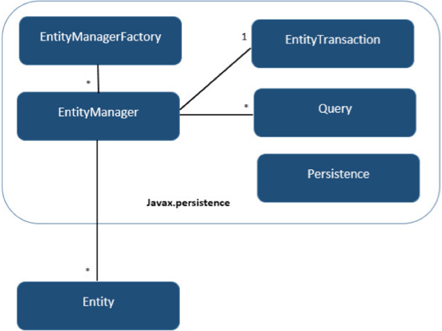
Screen-I and II
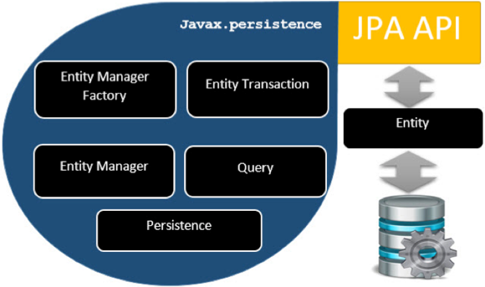

=>The following topics are addressed here to understand:
i)Entities
ii) Entity Inheritance
iii) Query Entity
iv)Managing Entities
v)Further Information about the Persistence

i)Entities:
=>Entiry is a lightweight persistence domain object. Typially, an entity represents a table in a relational database, and each entity instance corrospond to a row in a table. The primary programming artifact of an entity si the entity class, although entities can use helper classes.
=>The persistent state of an entity is represented although either persistent fields or the persistent properties. These fields or properties use object/relational mapping annotation to map the entities and entity relationship to a relational datat in the underlying data store.
=>Requirements for the entity class
->The class must be annotated with javax.persistence.Entity annotation.
->The class must have public or protected, non-argumnt constructor. The class may have other constructor.
->The class must not be declear as final.No methods or persistence instance must be declear as final.
->If an entity instance is passed by value as a detached object, such as through a session bean's remote business inteface, the class must implement Serializable interface..
->Entity may extends both entity and non-entity classes, and non-entity classes may extends entity classes.
->persistence instance variable must be declear as private, protected or package-private and can be accessed directly only by the entity class's methods. Client must access the entityn state through accessor or business method.
=>Persistent fields and Properties in Entity Class.
-> The persistent state of an entity can be access through either the entity instance variable or properties. The fields or properties must be the following java language types:
- Java primitive types
- java.lang.String
- Other serializable types, including:
- Wrappers of Java primitive types
- java.math.BigInteger
- java.math.BigDecimal
- java.util.Date
- java.util.Calendar
- java.sql.Date
- java.sql.Time
- java.sql.TimeStamp
- User-defined serializable types
- byte[]
- Byte[]
- char[]
- Character[]
- Enumerated types
- Other entities and/or collections of entities
- Embeddable classes
ii)Entity Inheritance:
=>Entities support class inheritance, polymorphic, association, and polymorphic queries. Entity classes can be extend non-entity classes, and non- entity classes can extend entity classes. Entity class can be both abstract and concrete.
=>Abstract Entities:
->A abstract class may be declear an entity by decorating the class with @Entity. Abstract entity are like concrete entity but can not be instantiated.
->Abstract entites can be queried just like concrete entities. If an abstract entity is the target of query, the query operates on all the concrete subclass of the abstract entity:
@Entity
public abstract class Employee{
@Id
protected Integer employeeId;
...
...
}
@Entity
public abstract class FullTimeEmployee extends Employee{
protected Integer salary;
}

iii)Querying Entities:
The Java Persistence API provides the following methods for querying entities.
- The Java Persistence query language (JPQL) is a simple, string-based language similar to SQL used to query entities and their relationships. SeeChapter 34, The Java Persistence Query Language for more information.
- The Criteria API is used to create typesafe queries using Java programming language APIs to query for entities and their relationships. See Chapter 35, Using the Criteria API to Create Queries for more information.
Both JPQL and the Criteria API have advantages and disadvantages.
Just a few lines long, JPQL queries are typically more concise and more readable than Criteria queries. Developers familiar with SQL will find it easy to learn the syntax of JPQL. JPQL named queries can be defined in the entity class using a Java programming language annotation or in the application’s deployment descriptor. JPQL queries are not typesafe, however, and require a cast when retrieving the query result from the entity manager. This means that type-casting errors may not be caught at compile time. JPQL queries don’t support open-ended parameters.
Criteria queries allow you to define the query in the business tier of the application. Although this is also possible using JPQL dynamic queries, Criteria queries provide better performance because JPQL dynamic queries must be parsed each time they are called. Criteria queries are typesafe and therefore don’t require casting, as JPQL queries do. The Criteria API is just another Java programming language API and doesn’t require developers to learn the syntax of another query language. Criteria queries are typically more verbose than JPQL queries and require the developer to create several objects and perform operations on those objects before submitting the query to the entity manager.

Similarity Between Hibernate and JPA
=>JPA is an interface for persistence providers to implement. Hibernate is one such implementation of JPA.
=>Hibernate and JPA both are ORM.
=>JPA and Hibernate both are use to perfrom the operation on database's records like save, update, delete etc.

Difference between Hibernate and JPA
JPA | Hibernate
JPA is the specification accessing, persesting, and managing the data between the Java object and the relational database.As the Definition it says, its API, It is only the API. There is no implemetaion for API. JPA specifies the set of rulesand guideline for developing the interface that follows the standards. | Hibernate is the actual implementation of JPA guidelines. When Hibernate implements the JPA implentation, This will be certify by the JPA Group upon the following all the standards mentioned in specification. For example, JPA guideline would provide information of mandatory and optional featuresto be implemented as a part of the JPA implementation.
JPA is just to guidelines to implement the Object Relational Mapping (ORM) and there is no underlying code for implementation. Ecilipse Link(Reference Implementation), openJPA etc. are the other implementation of JPA. | Hibernate is a JPA provider. When there is a new changes to the specification, Hibernate would be released its update implementation for the JPA specification.
In JPA, to open the session EntityManagerFactory is used. | In the Hibernate, to open the session SessionFactory is used to manange the session.
JPA provides set of Interface which must be implemented. There are always reference implementation available for language speciafication.In this case EclipseLink is reference implementation. | Hibernate on the other hand, does implementation JPA specification but it also has its own native API.

